HUM 100 Worksheet: Realism, Impressionism, and the Modern World

Part 1:

Realism |  | Impressionism
Characteristics:  1. Depiction of the ordinary  2. Real-life situations  3. Shift from the ideal to the real |  | Characteristics:  1. The play of light in the present moment  2. Immediacy, spontaneity  3. Short, staccato brushstrokes in art
Artifact | Characteristic It Represents(Explain Your Reasoning) | Artifact | Characteristic It Represents (Explain Your Reasoning)
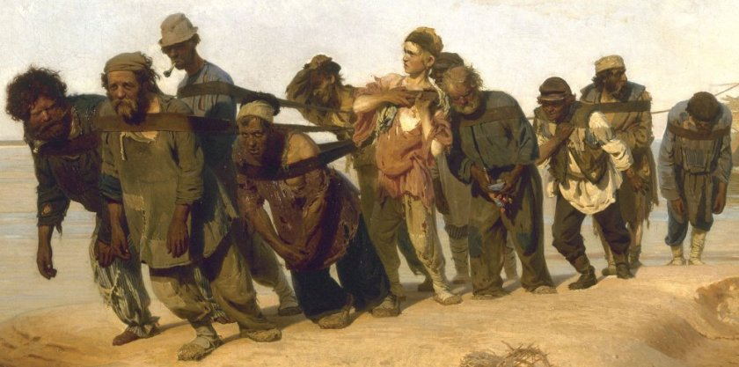  Ilya Repin, Barge Haulers on the Volga , 1873,Oil on Canvas, 131.5*281cm (State Russian Museum, St.Peterburg).  https://mydailyartdisplay.wordpress.com/2012/07/05/barge-haulers-on-the-volga-by-ilya-repin/ | Ilya Repin, focused on presentation of ordinary life situations, real life aspects as well as a shift from the ideal to the real.  Ilya Repin had his roots from realism and achieved excellent realistic interpretations which he presented in his paintings.  In Barge Haulers on the Volga, he portrays a group of 11 men who are in rags and they are dragging a barge on a river bank.  As evident, the men are at the verge of collapsing and they are exhausted as a result of the heavy luggage and the hot weather (Cross 35). This work presented the experiences of the Russian men especially the peasants and the slaves. The men seem defeated and through the painting , Ilya presented a true picture of a tortured society and condemned the profit coined from inhuman labour and peoples’ suffering.  The painting also depicts the hard work and the heroic acts of the Russian men and peasants during that time. | 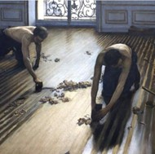  Gustave Caillebotte, The Floor Scrapers, 1875, Oil painting on Canvas, 1.92 m x 1.46 m  (Musee d’Orsay, Paris).  http://www.visual-arts-cork.com/paintings-analysis/floor-scrapers.htm | Gustave Caillebotte was an impressionist and his art work was motivated by the French Impressionism. In his work, he intertwined colour with light and also relied on Short, staccato brushstrokes.  Gustave Caillebotte used short choppy brushstrokes in an attempt to present a clear image of the floor as well as the semi-nude floor planners.  The planners are on their knees and are working on hands while scraping the floor. In the painting, there is a window that lets light inside and this aids in illumination (Caillebotte & Anne 45).  The light is reflected on some sections of the floor and also on the back of the workers .The light is also used in changing the atmospheric conditions of the apartment and the painting

Part 2:

Modern World
Person | Artifact Created | Medium | Need to Express
20th Century:  Pablo Picasso | Guernica | Visual Art | In Guernica, Pablo Picasso, presented the tragedies which are evident in a society which is rooted in the culture of war and conflicts. As noted from the painting, war leads to suffering and pain among individuals as well as the innocent civilians. Picasso developed the painting in response to the repercussions of the Spanish Civil war.
21st Century:  Mickalene Thomas | Le déjeuner sur l’herbe: Le Trois Femme Noires, | Visual Art | Le déjeuner sur l’herbe: Le Trois Femme Noires was used to present the relationship between the black woman, art, history and the contemporary culture. The visual art also presents glamorous black women and explores aspects of concern to beauty, race as well as identity.

In one to two sentences, answer the following questions: What differences do you notice between the artifacts from each era? In the context of what you have learned in this theme, where do you think those differences stemmed from?

Realism art work was very objective and sought to present an honest view of the contemporary life and there was a very high reliance on real pictures in presenting real life experiences. Realism did not glamorize life in any way. The artifacts in the impressionism era presented a movement feeling and this is the reason they relied on loose brush strokes, sketchy lines as well as colors.
The impressionism artists captured life in an aspect of impression and also romanticized it. The contemporary art blends many aspects and it is mostly characterized by aspects of creativity as well as innovation. These differences emanate from the objectives of the artwork of each time. As noted, realism sough to present real life experiences , impressionism intended to depict the professionalism of the artist and feelings while modern art depicts innovation and creativity.

Works Cited.
Cross, Samuel H. "Nineteenth Century Russian Painting." American Slavic and East European Review 4.3-4 (1945): 35-53.
Caillebotte, Gustave, and Anne Distel. Gustave Caillebotte, urban impressionist; Barge Haulers on the Volga, Abbeville Press, 1995.
https://mydailyartdisplay.wordpress.com/2012/07/05/barge-haulers-on-the-volga-by-ilya-repin/
http://www.visual-arts-cork.com/paintings-analysis/floor-scrapers.htm

